Testing
Below is a test table for a variety of different tests to the calculator. All the tests were run on the physical hardware, but I have taken screenshots of the version of the program that runs on my computer for ease - there is no difference between the workings of them for testing purposes. I have highlighted results in green where the tests have passed, yellow where they have passed but perhaps not entirely as intended, and red where they have failed.
Objective | Input | Expected | Actual
Test how not filled functions work | sin() | Returns some form of error message | Puts a box where I did not enter anything

Functions that are undefined at certain ranges | x^x | Doesn’t show anything there | No values appear where the function is undefined (x<0)
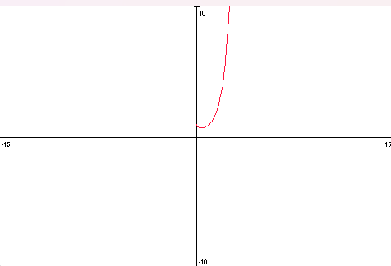
Adding things that should move the cursor does | x^2 | When you press the button “x^n”, the cursor moves to be in the power | The cursor stays in the original number rather than moving to the superscript.
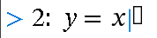
Functions that are undefined everywhere | x/0 | When you press “exe” either an error is sent or nothing is displayed. | An empty grid is displayed.
Entering a negative range | x: 10 - 0 | An error message is displayed | Axes are flipped, but graphs are not plotted
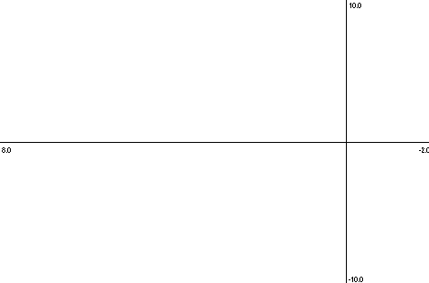
Entering negative values for rows | x: -100 - -20 | The graph has an x-range from -100 to -20 | You cannot enter negative numbers in the range
Putting a range of 0 | x: 0 - 0 | An error message is displayed | The program crashes
Putting a very large range | x: 0 - 999,999,999,999  u: 0 - 999,999,999,999  y = x | The program might run or might return an error message | The box for the range does not expand with the number, so it goes outside the box. The numbers can also overlap with each other and go off the screen.
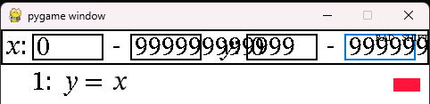
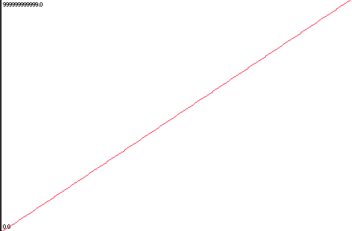
Entering multiple decimal points in a number in a function | y=1.0.1 | An error message is displayed | The function disappears
Entering multiple decimal points in a number in the range | x: 0.0.1 - 3.0.5 | An error message is displayed | The range is reset to the default
Entering a function that is invalid | y = x.sin(x) | An error message is displayed | The function disappears
Entering a variable in the range | x: x - 2x | An error message is displayed, or you are not allowed to enter that key | You are not allowed to enter that key
Trying to move to a function below function 7 | Down key when function 7 is selected | Reveals more functions or loops back to the top | Loops back to the top
Derivatives and integrals | Press integral/derivative button | Makes a derivative or integral when pressed | Nothing happens
Pressing the move keys moves the centre of the screen in that respective direction | Press right, then up, then left, then down keys | Moves the screen to be centred on something to the right of the current position, then up, then left, then down. | Moves the screen to be centred on something to the right of the current position, then up, then left, then down.
Zoom in or out | Press zoom in/zoom out | The screen zooms in/out, keeping centre of the screen at the centre | The function zooms in to show a smaller region of the graph or out to show more, but when it is not centred on 0, the centre moves around
Zooming into a function that has a pole (a point where a function is undefined) | y = 1/x and x/x -1 and y = x ln (abs(x))  zoom into the middle | It zooms in to the centre of the screen, and displays the right value at the pole | It still zooms properly, and it seems to converge to a pole (e.g. 0 for x/x-1, but the value close to the pole isn’t displayed.
Pressing the off button | Pressing the off button in the function entering menu and the graph menu | The device turns off | The device turns off when in the entering menu, but not when in the graph menu.
Pressing numbers does as expected | Enter 0,1,2,3,4,5,6,7,8,9, ”.” | That number is entered into the selected box | That number is entered into the selected box

Pressing lots of divisions | Enter 1/1/1/1/1/1/1/… | It either keeps going or reaches a limit and stops letting you divide | You can keep entering more divisions, but the fractions keep getting smaller until you can’t see them.
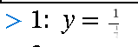
Pressing lots of roots | Enter sqrt(sqrt(sqrt(…) | The square roots keep going and maybe reaches a limit | You can keep entering square roots, but the lines fade and get very small.
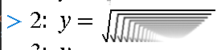

Objectives testing
Below is a test table specifically for the objectives created in the analysis section. Results have been highlighted following the same colour scheme as above, and for cases of plotting graphs, I have used Desmos to provide a representation of what the graph should look like.
Objective | Input | Expected | Actual
Create a parser for arbitrary polynomials (1); generate a list of points for the graph (2); create a mock display for testing (3) | 3x^3+x^2-2x+1 | 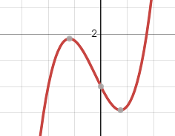 | Plots the graph as below
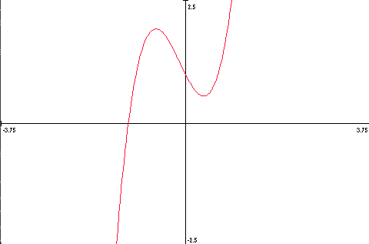
Add zoom function (4a) | 3x^3+x^2-2x+1, zoom in | Graph zooms in | Graph zooms in
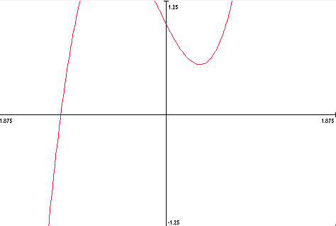
Add move function (4b) | 3x^3+x^2-2x+1, left key | Centre moves left (graph moves right) | Centre moves left (graph moves right)
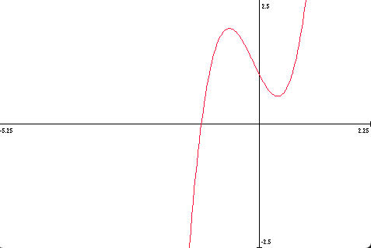
Radical equations (5a) | 5th root of (x+3) | 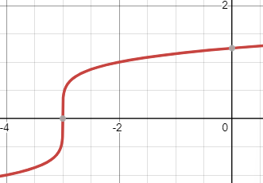 | Plots the graph as below
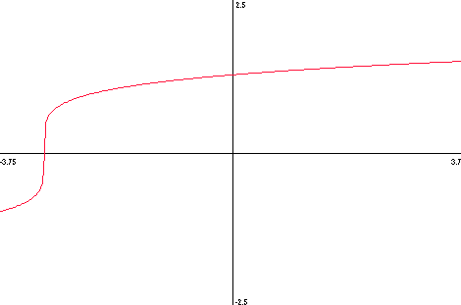
Exponential equations (5b) | e^x | 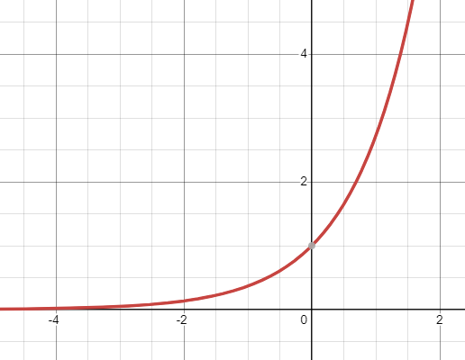 | Plots the graph as below
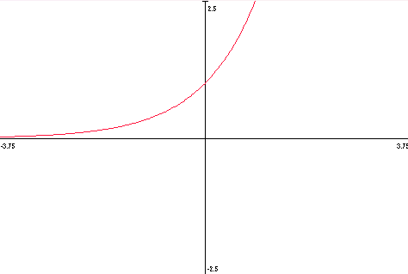
Reciprocal graphs (5c) | 2/x | 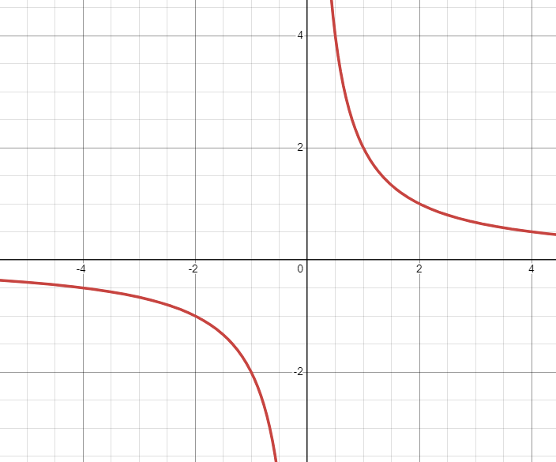 | Plots the graph as below
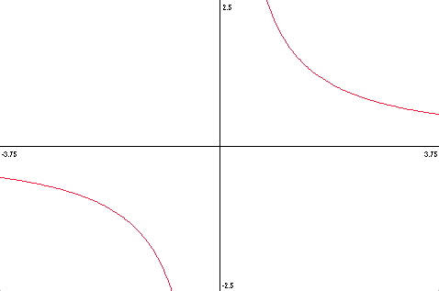
Logarithmic equations (5d) | Log base 5 of x | 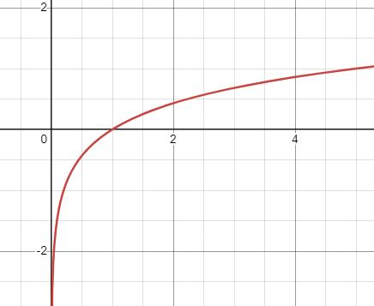 | Plots the graph as below
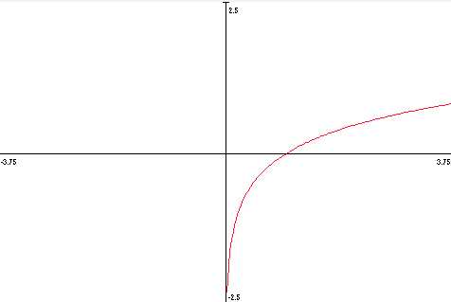
Main trigonometric functions (5ei) | tan(x) | 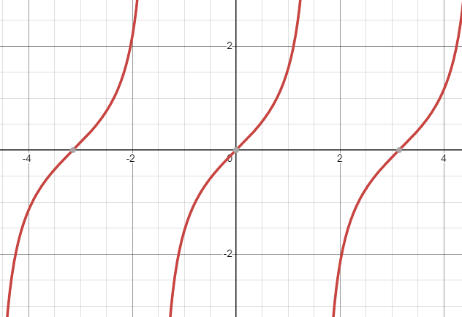 | Plots the graph as below but asymptotes plot as straight lines
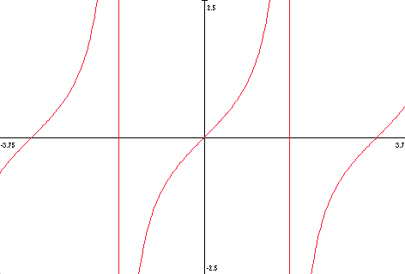
Reciprocal trigonometric functions (5eii) | csc(x) | 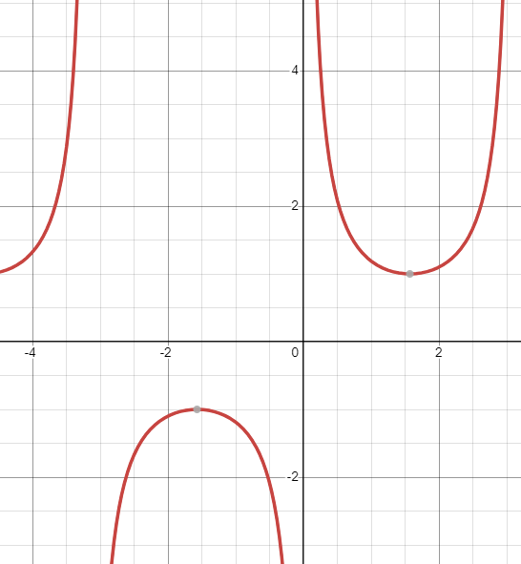 | Plots the graph as below but asymptotes plot as straight lines
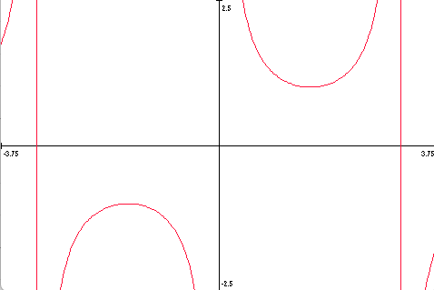
Parametric equations (6) | N/A | Parametric equation plotted | Not implemented yet
Calculus (7) | N/A | Derivative/antiderivative plotted | Not implemented yet
Multiple equations (8) | csc(x), sqrt(x), x^2, cos(x) | 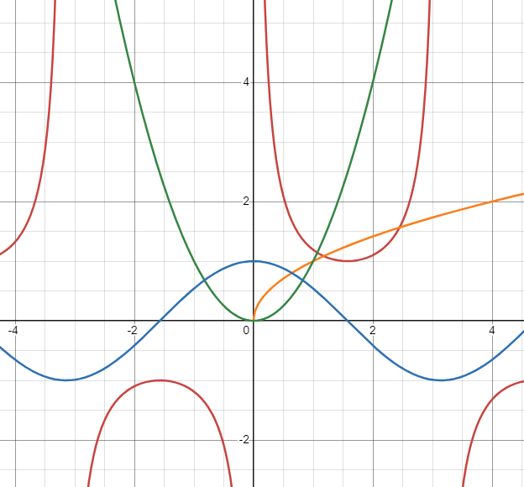 | Graphs plotted as below
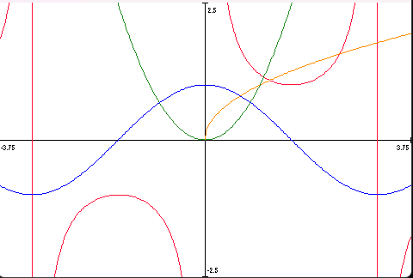
Design physical calculator (10), build physical calculator (11) | N/A | Calculator works as a portable device | Calculator works as a portable device - see below
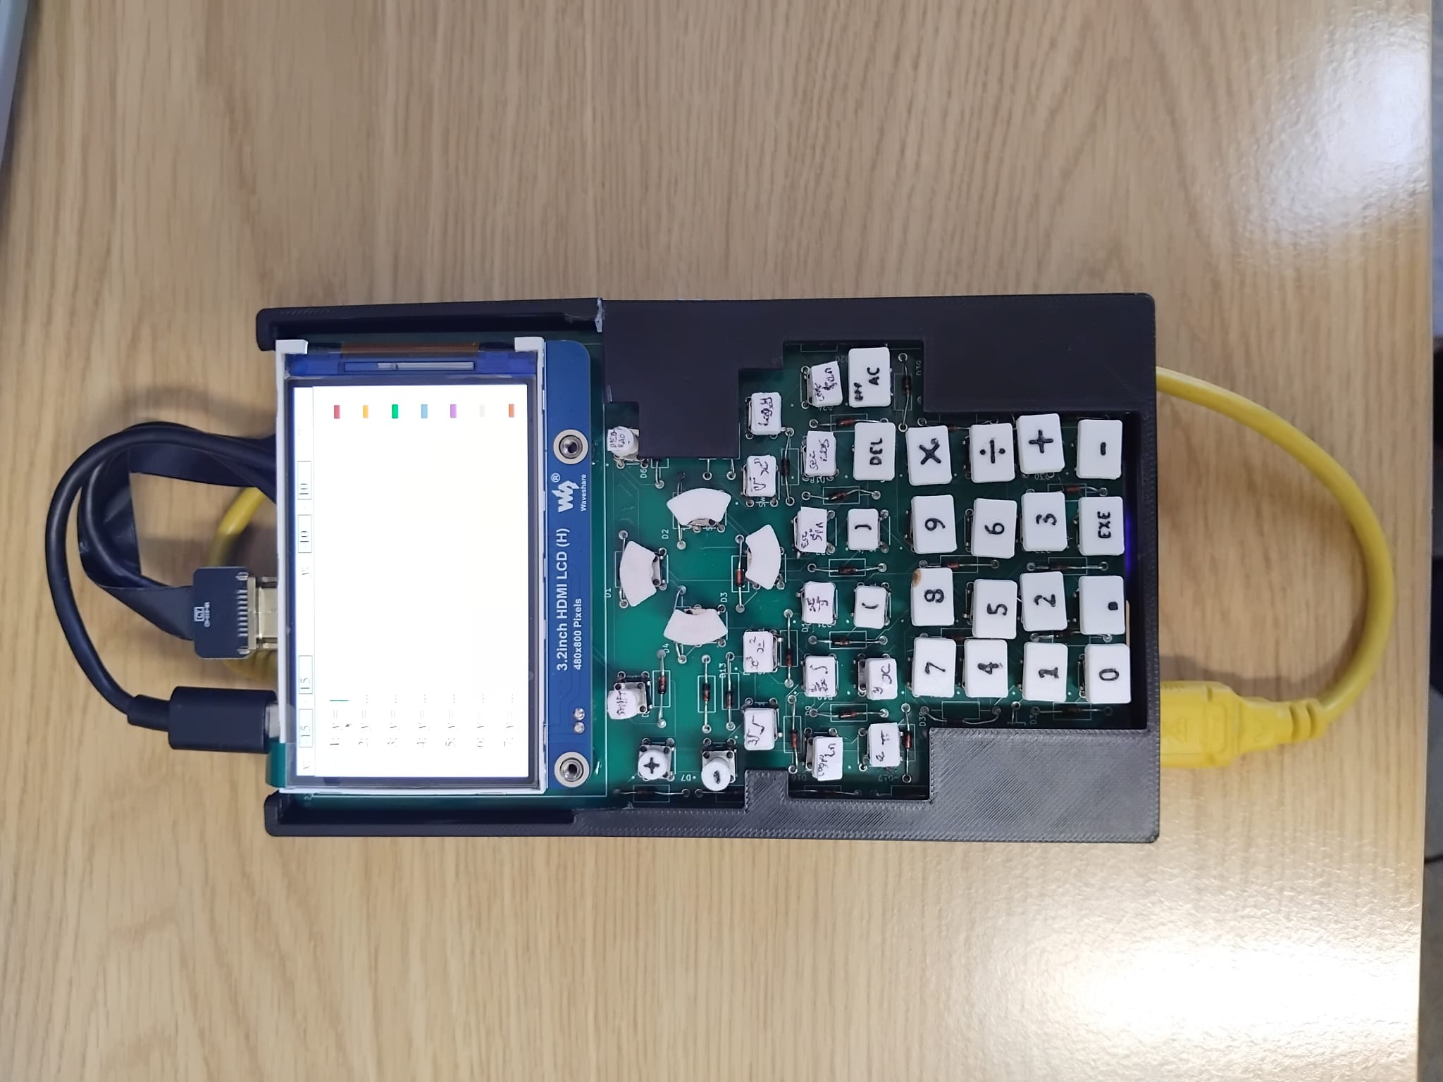
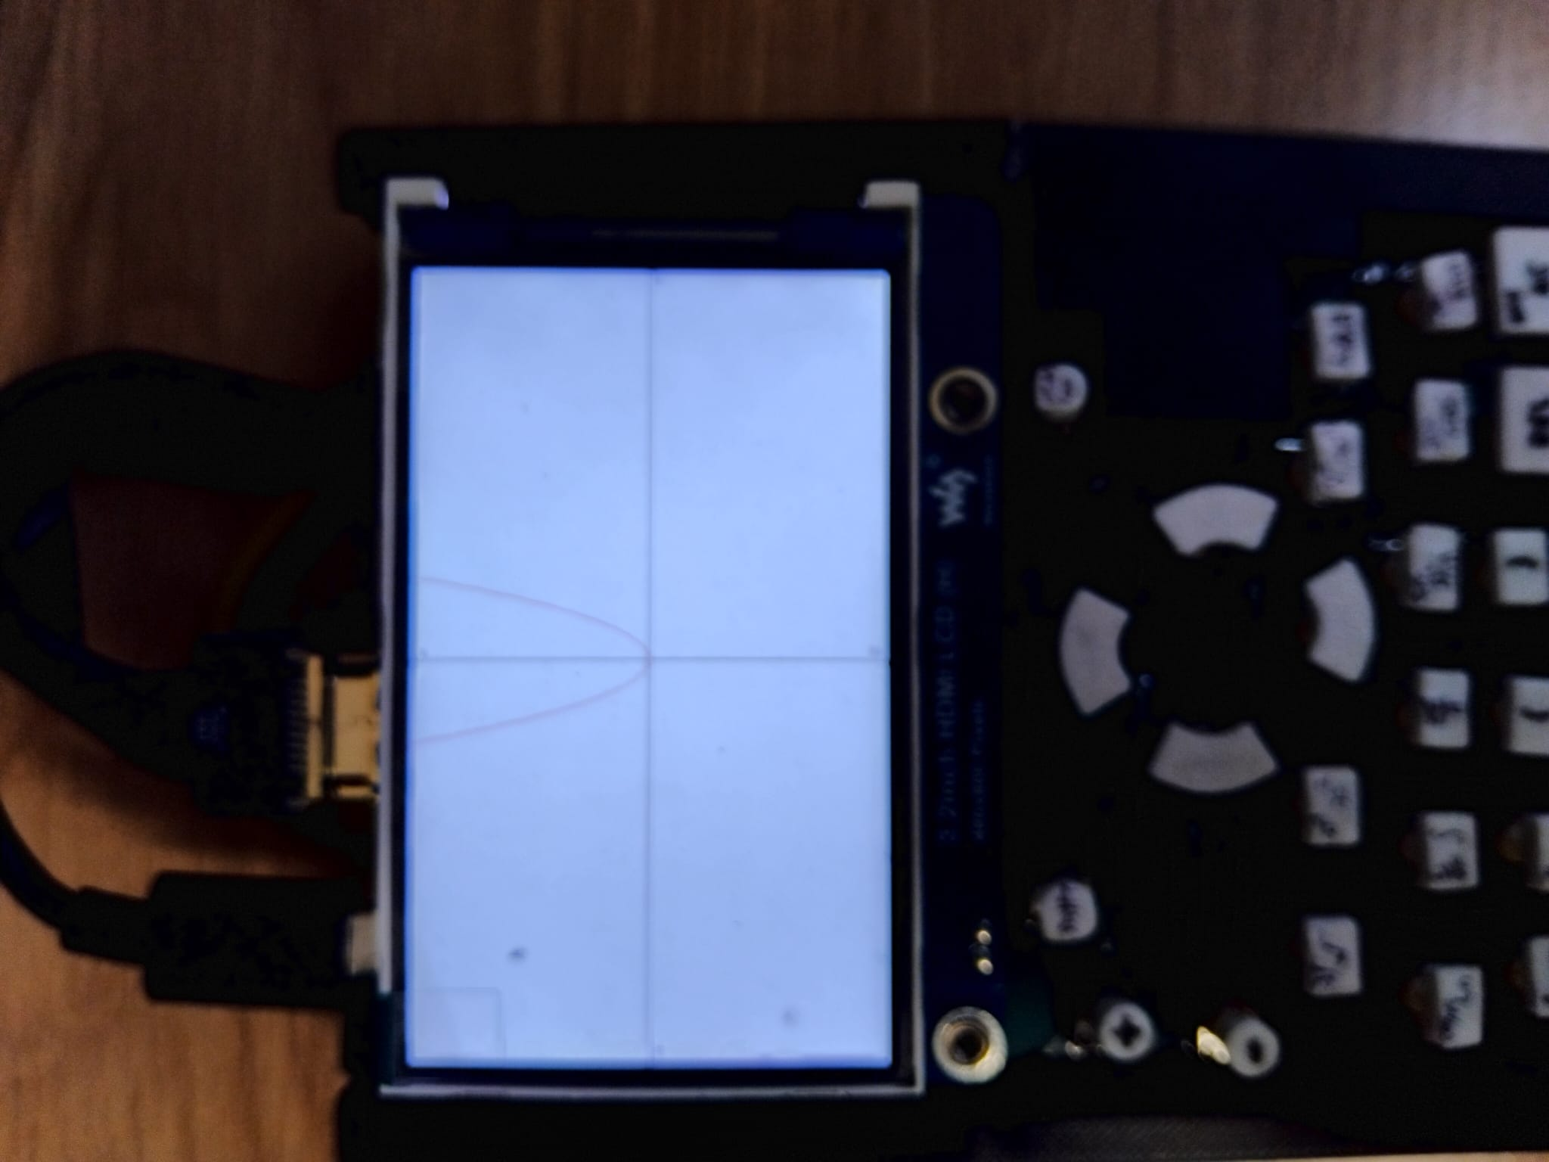
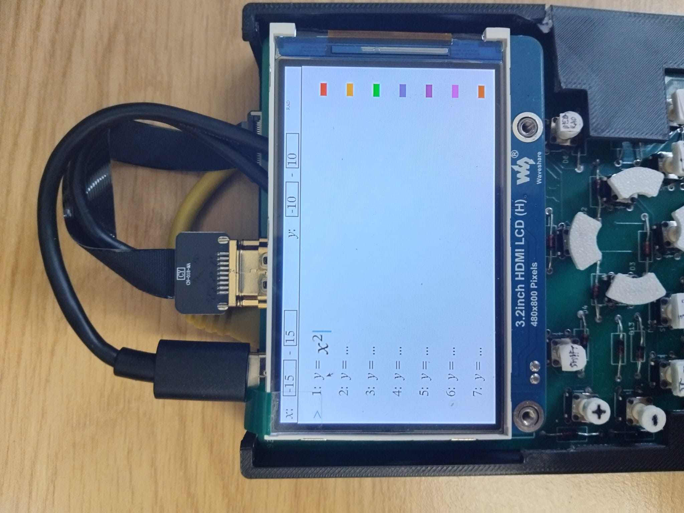

Fixes

Most of the tests passed, as can be seen, but some failed, and some work but not quite as intended. Below I will detail the problems with each of the tests which did not go as expected, and how they could be fixed. I will implement the fixes for the ones that can be easily fixed as well.
One of the problems is that when an exponent is inputted, the cursor stays in the base rather than moving to the superscript, because the user has to input the base after the exponent. In most calculators, entering an exponent automatically puts the previous token into the base. I had not implemented this for my calculator as I only tokenise the inputs at the parsing stage, so the only way to do it would be to use the previous object, and this would lead to problems such as 25^2 being parsed as 2*5^2. However, I have realised that generally for graphing purposes, the user will only be putting a function or a variable to an exponent, which is only represented as one object, so I have implemented this as seen below:
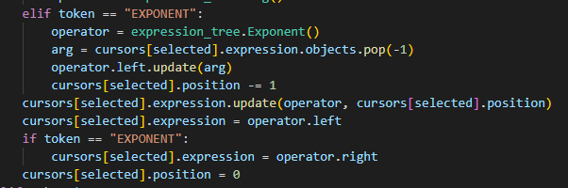
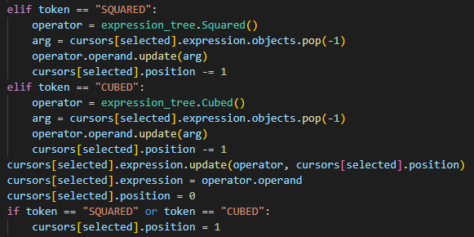
Now the previous character is automatically made into the base of the exponent, and the cursor moves to the exponent when necessary.

Another problem was that the user could enter a negative range, such as 10-0, in the view window. This should not be allowed, so I have added input validation for the view window:
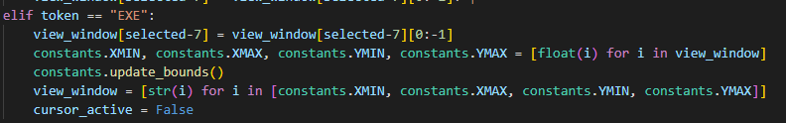
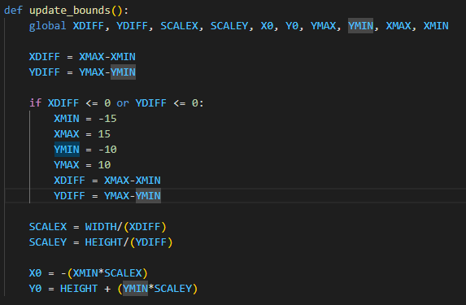
As can be seen, I have made it so that when the graph screen loads and the bounds are updated, it checks then whether the bounds are valid or not, and if not, resets them.

Another problem was that negative numbers cannot be inputted into the view window: this was a quick fix as it was just something I missed in input validation.
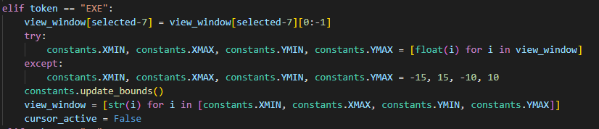
I have also added a try except block to catch any errors pertaining to the negative numbers without resetting the entire program, such as if the user types a negative sign not at the start of a number - when triggered, the view window is just reset to the default.
This also fixes the problem about the view window having a zero range and crashing the program - as it is validated this no longer happens.

When entering a very large number in the view window, the number goes off the screen and out of the box. I have thought about this but decided to not fix it, as I believe it is more helpful to the user to let arbitrarily large view window values be input than to make the inputs look aesthetically pleasing and thus cap them at a certain point. A scroll feature would be more confusing to the user I think, especially on a small screen with just the move buttons for controls.

Derivatives and integrals are not implemented, so they do not work - in the future I would like to add them but I have not had time to, what with the scale of the project being larger than expected. Similarly, I have not yet implemented parametric equations.

Zooming in and out on the graph display screen did not work properly when the centre was not (0,0), and I have now fixed this. Previously it simply halved or doubled the bounds, which doesn’t keep the centre the same - now it takes into account the distance between the centre and the bounds.
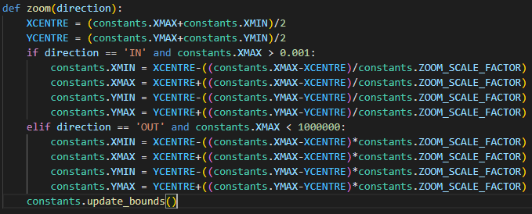

Zooming into a pole does not show values directly round the pole - this is because they get so big or so small that they are not plotted, and is expected behaviour, although does make the graph look discontinuous at points other than the pole.

The device does not turn off in the graph screen - I have decided to keep this as the shift button does not give graphical updates to the user when in the graph screen, and is only defined for the input screen, so I feel it is best not to implement it for the graph screen to avoid cluttering the screen and making it more confusing to the user.

Pressing lots of nested fractions and nested square roots makes them so small that they cannot be seen - there is not really a way around this other than capping them, which I do not want to do as it reduces the amount of freedom that the user has. I could try to implement some scrolling mechanism but, similarly to with the view window, I feel that it would be quite clunky with just the arrow buttons for the user to move and would clutter the screen more and make it more confusing.

